Chapter 4, Problem 41.

Find the Thèvenin and Norton equivalents at terminals a-b of the circuit shown in Fig. 4.108.

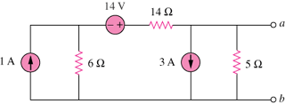

Figure 4.108
For Prob. 4.41.

